TRAFFIC REGULATION NOTICE
ROAD TRAFFIC REGULATION ACT, 1984

Notice is hereby given pursuant to Section 14(2) of the Road Traffic Regulation Act, 1984, that the Oxfordshire County Council

TEMPORARILY PROHIBITS THE USE OF THE HIGHWAY
BY ALL MOTOR VEHICLES

LOCATION: Old Marston Arlington Drive

REASON: Thames Water maintenance work

DURATION:

(Traffic Regulation Notices cover a maximum of 5 consecutive days)

ACCESS: Limited access will be maintained for emergency service vehicles and for frontages within the closed section of road, subject to the progress of the works

SUGGESTED ALTERNATIVE ROUTE: The alternative routes for traffic are
via a combination of Arlington Drive – Salford Road – Cavendish Drive –
Arlington Drive and vice-versa.

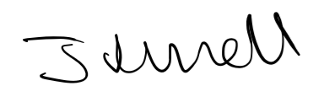
Jason Russell, Director for Infrastructure Delivery
Communities

Date: 16 September 2020

